**NAME :- Shantanu Rana**

**SAP ID :- 500082398**

**LAB EXERCISE 3**

**Aim: Maven Build and usage in other Java Project**

1. Create a Build of java project using maven.
2. Use that build in some other Java Project.
3. **Create a Build of java project using maven.**

Step 1:- First I created a maven project devops.lab3 and added a class in it and written code for subtraction and Addition.

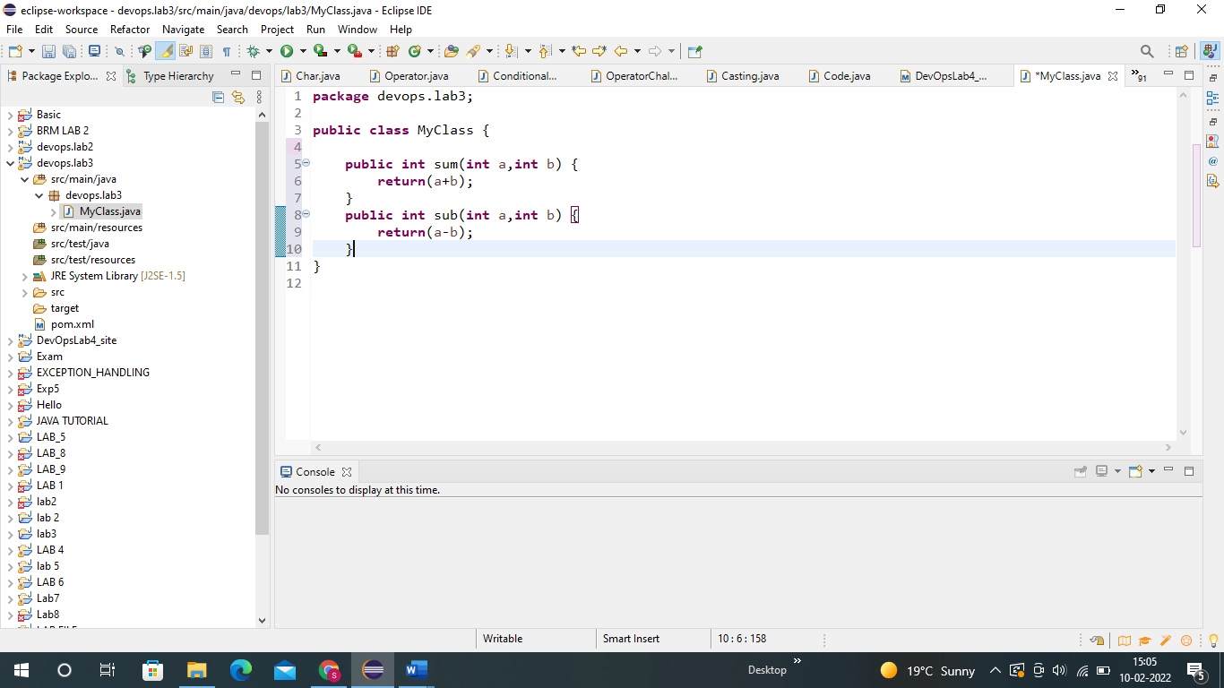

Step 2 :- Now I will execute Maven build and set Goal as clean.

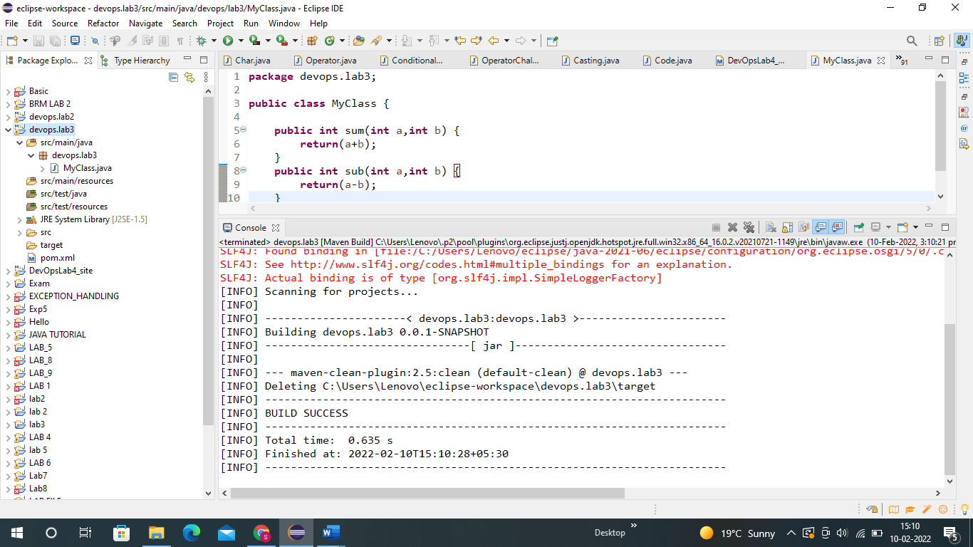

It’s Showing BUILD SUCCESS !!!!

Step 3 :- Now I Have added Dependency in pom.xml file.

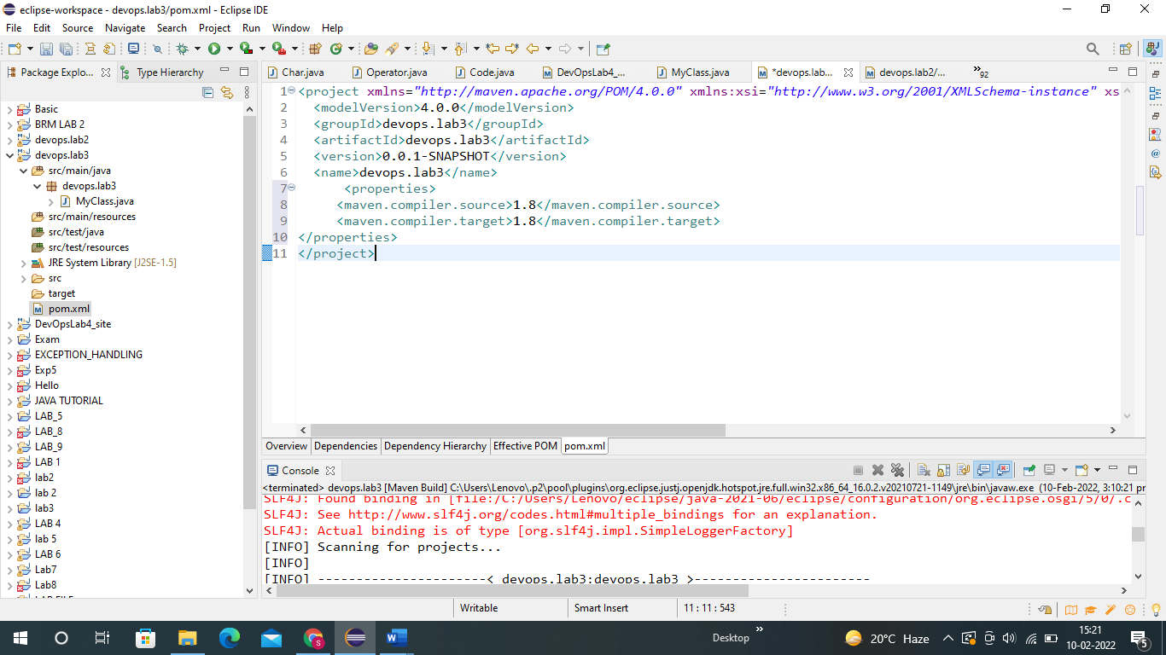

After that I did build and set goal as install.

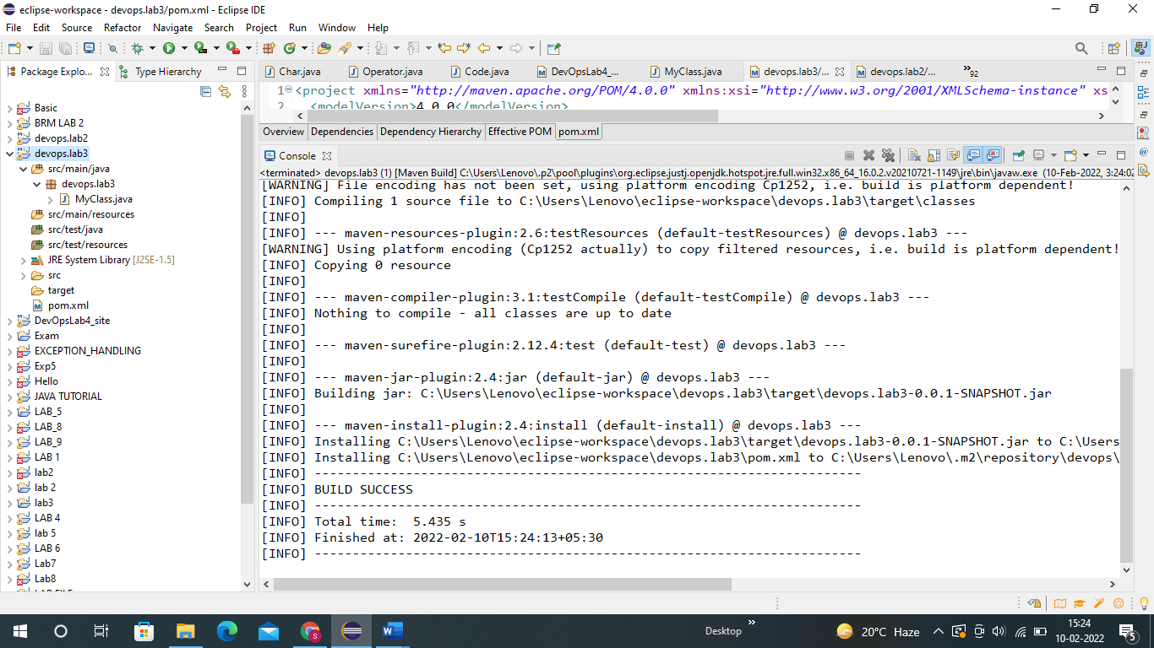

Again BUILD SUCCESS !!!!

Step 4 :- Now I have created a new java project.

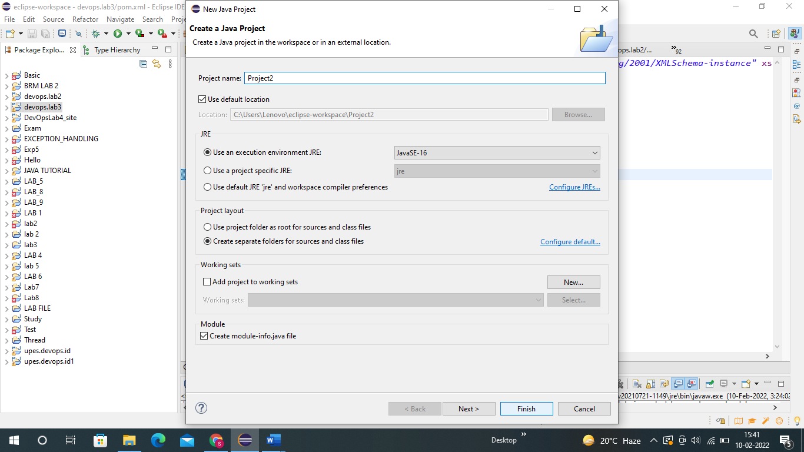

1. **Use that build in some other Java Project.**

Step 5 :- Now in the Java project I created a package pkg2 and inside that package I created a class named MyTestClass.

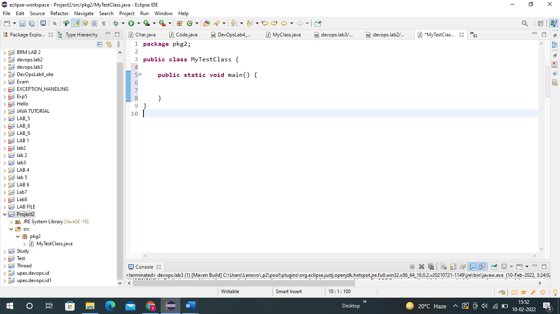

Step 6 :- Now right click on java project and Then click on Build Path and then on Configure Build path..

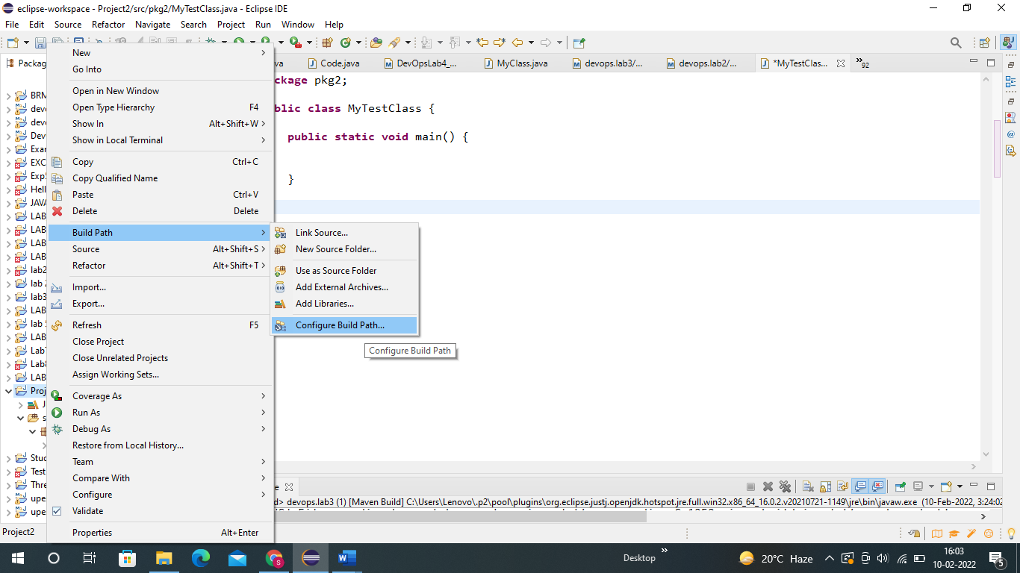

Step 7 :- Now click on libraries and then on Classpath and then click on Add External JARs.. and click on Apply and Close.

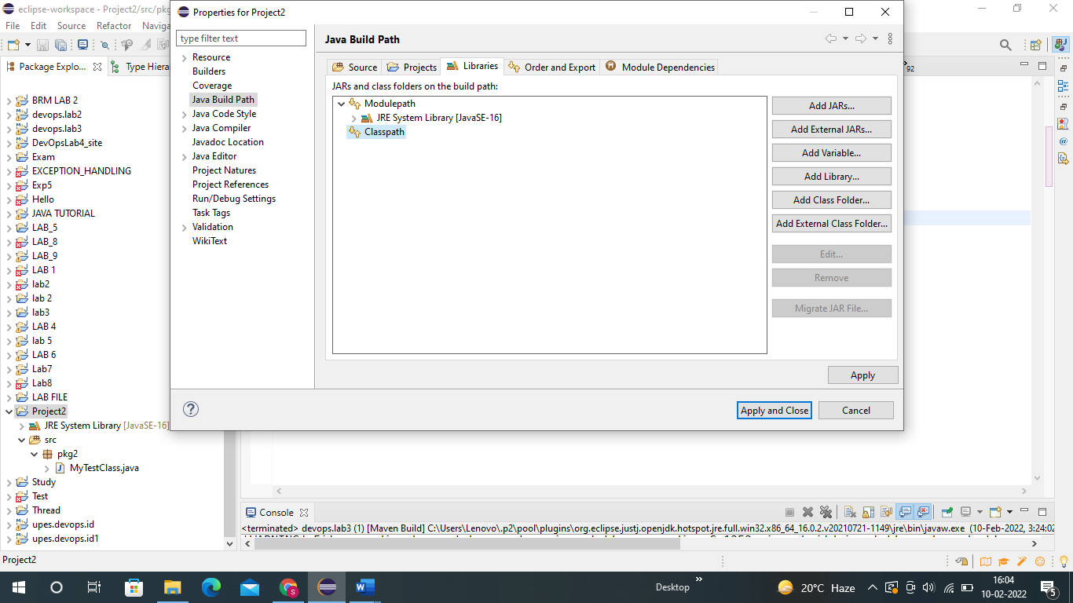

Step 8:- Now add the jar file and open it.

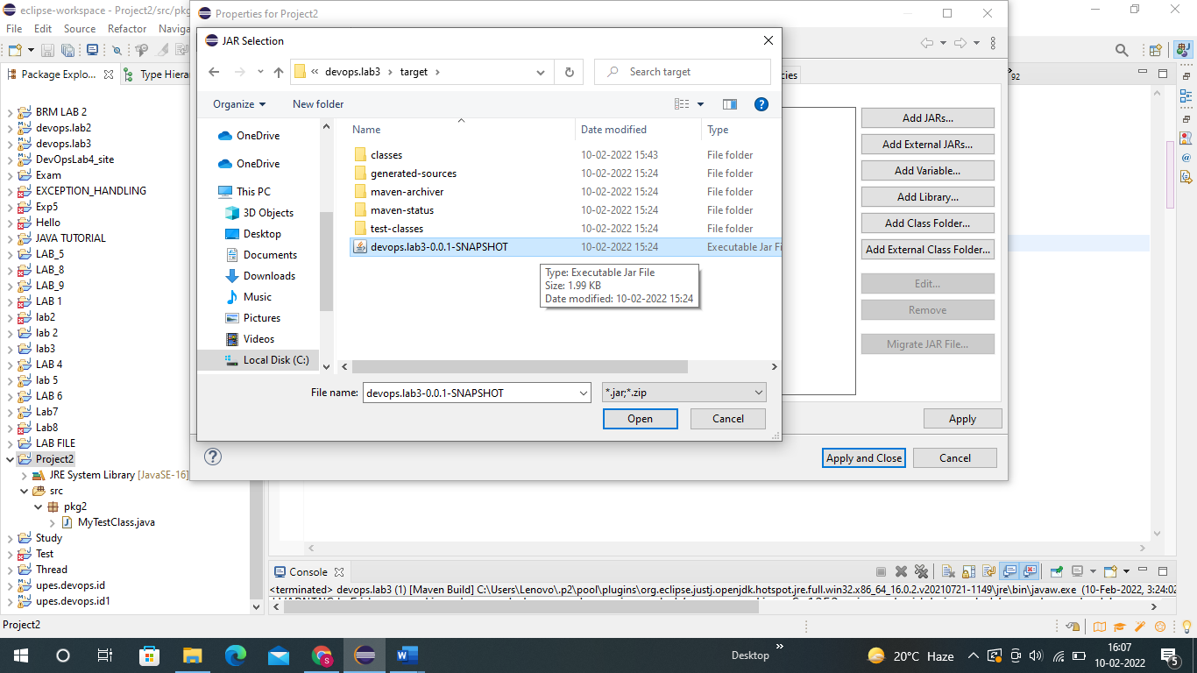

**Step 9 :- Now I have deleted the class from maven project and after deleting also we will see the Class will give output.**

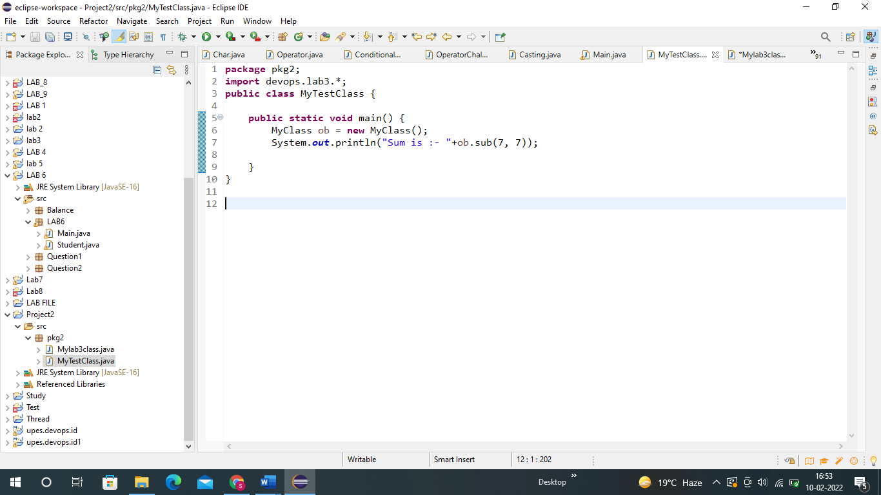

**OUTPUT :- 14**

This is because the code is not important now. We have created a build of code and we have a jar file of deleted class from maven.

**THANK YOU**

package devops.lab3;

public class MyClass {

public int sum(int a, int b) {

return(a+b);

}

public int sub(int a, int b) {

return(a-b);

}

}